Bahria University,

Karachi Campus



LAB EXPERIMENT NO.

**2**

LIST OF TASKS

|  |  |
| --- | --- |
| TASK NO | OBJECTIVE |
| **1** | Create Windows Virtual Machine in Azure |
| **2** | Install different software on the created VM (including VS Code and Dev++). |
| 3 | Create simple login and sign-up page on VS Code using VM. |

Submitted On:

25 February 2024

____________

(Date: DD/MM/YY)

**Task 1**

Create Windows Virtual Machine in Azure

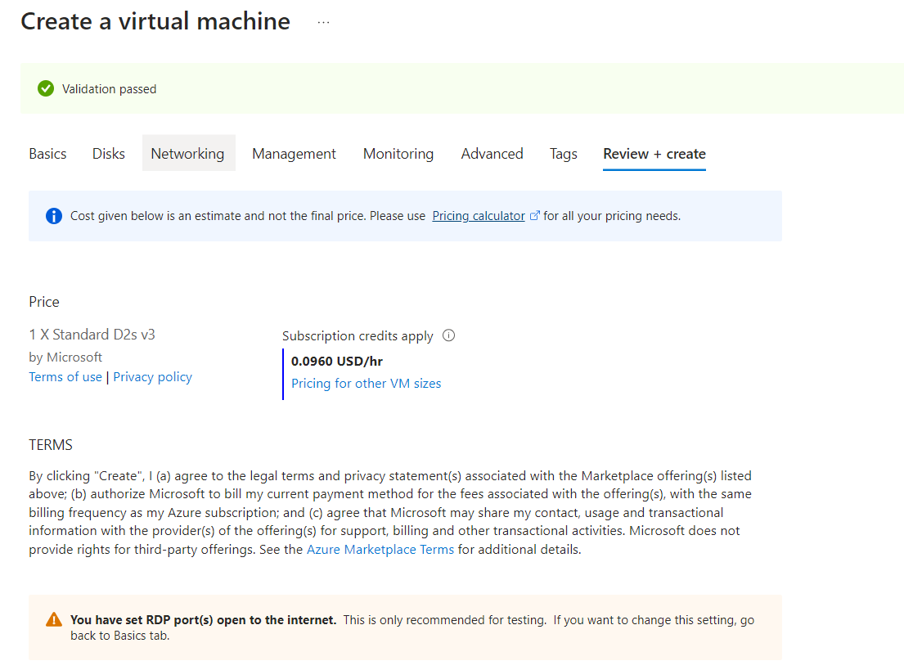

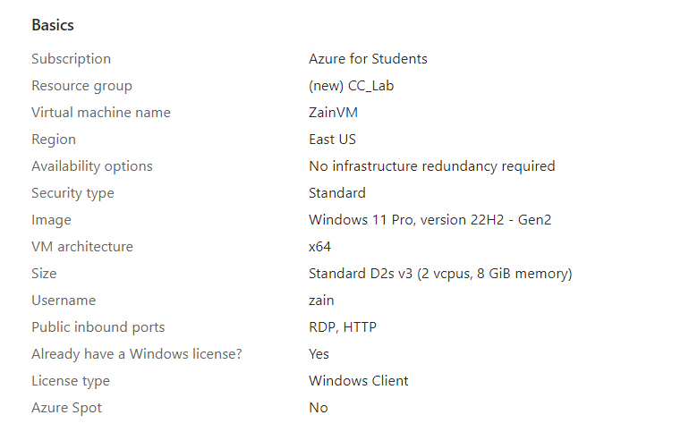

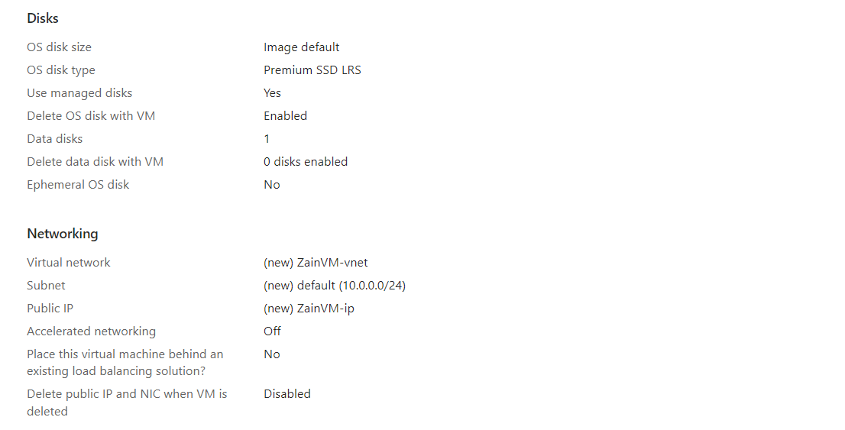

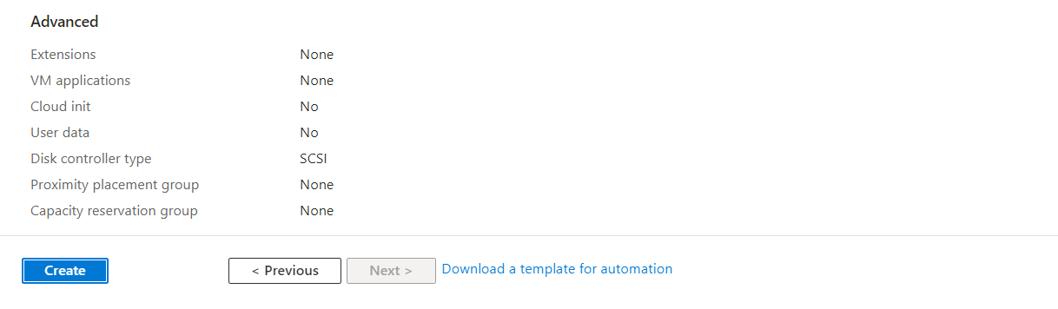

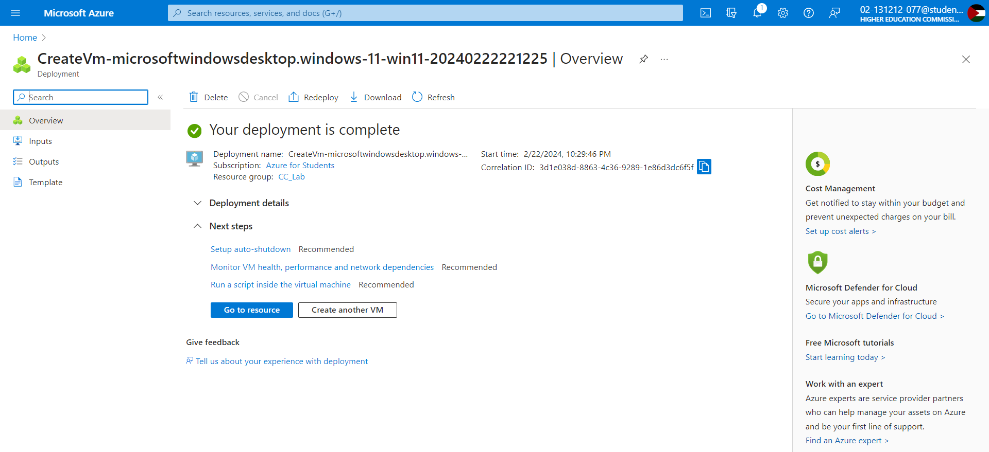

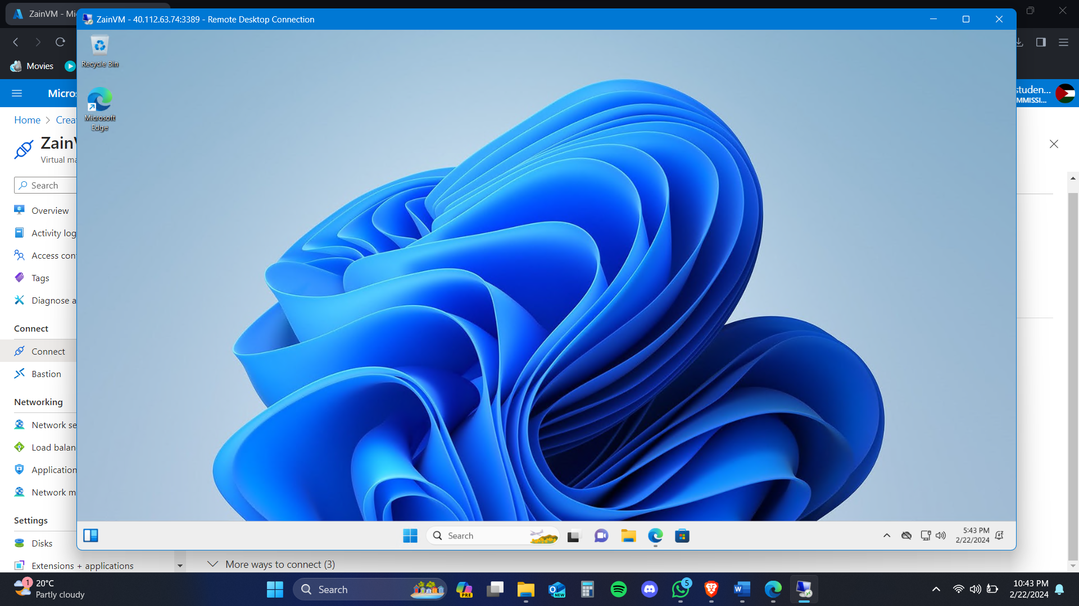

**Task 2**

Install different software on the created VM (including VS Code and Dev++)

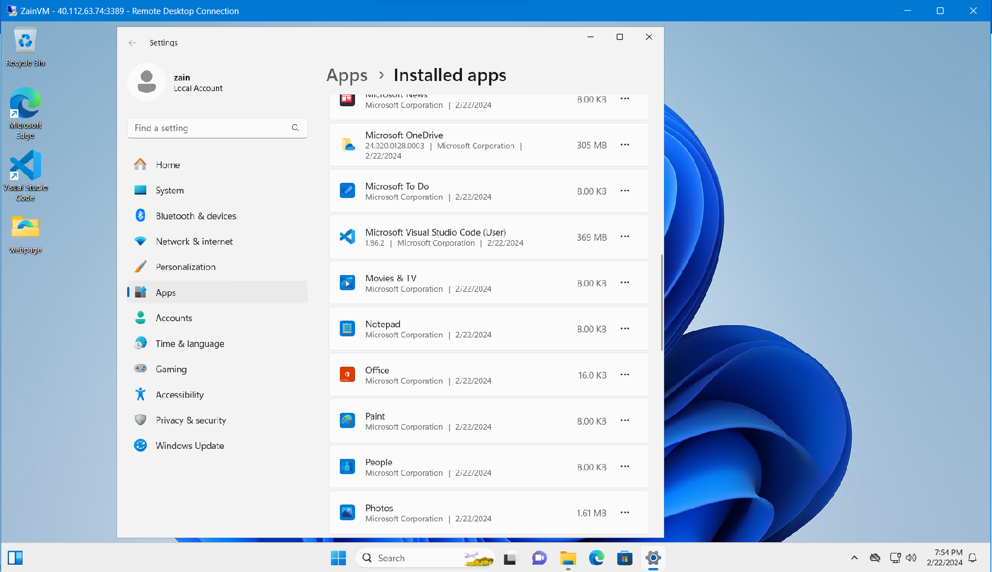

**Task 3**

Install different software on the created VM (including VS Code and Dev++)



